Pastoral Care Policy

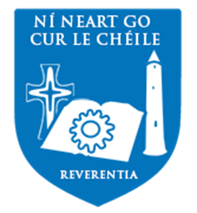

Contents

Contents 1
Core Values 2
Pastoral Approach in Our School 2
Pastoral Structure 2
Roles and Responsibilities 3
Board of Management 3
Principal 3
Deputy Principals 3
Year Head 3
Class Tutor 4
Subject Teacher 5
Chaplain 5
Career Guidance Counsellors 6
Ancillary Staff 6
Special Education Team 7
Inclusivity 7
Pastoral Care Team 8
School systems / structures which support the Pastoral Care Team 9
Pastoral Programmes 9 Pastoral Procedures 1​1
Ladder of Referral ​1​3
External Agencies 14

Related School Policies and Codes 14

External State Guidelines and Procedures 15

Core Values
Gort Community School strives to provide an environment of respect, care and inclusivity, for each member of its school community. The Pastoral Care System at Gort Community School is committed to providing an environment in which each pupil is appreciated and valued. This commitment is echoed in our mission, which states that: “Gort Community School is a multi-denominational school with a Christian ethos that welcomes all faiths. We encourage the holistic development of each student and the wellbeing of the school community. Individuality and diversity are respected in Gort Community School. We seek to promote a sense of respect for one another, in a safe and secure and caring environment. We foster growth and self-esteem by encouraging excellence in Teaching and Learning and by providing a balance of educational activities. Our School promotes equal opportunity and recognises the importance of partnership between the school and its stakeholders.”

Pastoral Approach in Our School
Pastoral care is central to all aspects of school life. Pastoral care can be defined as looking after the growth, development and well-being of all members of the school community through:
- Mutual Respect - reflecting the very essence of our motto “Reverentia”
- Responsibility - students are encouraged to take responsibility and be accountable
- Relationship of Trust - between staff and students
- Consistency - in the application of rules/standards

Pastoral Care at Gort Community School endeavours:
- To value and respect each member of the school community
- To ensure that every member of our community knows how to avail of support systems and procedures
- To encourage everybody to play their part in contributing to the pastoral ethos of this school community

Pastoral Structure
Pastoral Care permeates all areas of school life and therefore every member of the school community has a responsibility to cultivate an atmosphere of care and engender a sense of belonging to our school community. We recognise that there are key roles within the school community which carry specific pastoral dimensions and responsibilities. It is this structure that underpins the pastoral care approach in our school.
The system will only work if everybody is cognisant of the philosophy behind it which is that, Pastoral Care is the responsibility of every member of staff at Gort Community School and can only be successful if each member plays his/her part.

Roles and Responsibilities

Board of Management
The Board will have overall responsibility for the development and monitoring of the Pastoral Care Policy. ​​ The Board of Management is responsible for ensuring that the Pastoral Care policy meets standards required by the Department of Education and Science.

Principal

The Principal, on behalf of the Board of Management, has overall responsibility for ensuring that the pastoral care needs of school community are met. The Principal will work with the Board of Management and staff in the development of the policy, ensuring that proper structures and resources are put in place for its effective operation. In his role as Designated Liaison Person, the Principal will contact the relevant agencies in accordance with Child Protection Procedures.

Deputy Principals

The Deputy Principals will aid the Principal in overseeing the implementation of the Pastoral Care Policy. They have a specialist role in supporting staff who work with students who are facing challenges. They are key people who liaise with parents/guardians and external agencies to support students who require outside intervention. In the role of Deputy Designated Liaison Person, the designated Deputy Principal will, when required, contact relevant agencies in accordance with Child Protection Procedures.

Year Head

The Year Head is manager of his/her year group. He/she aims to foster a culture in keeping with the values and approach to pastoral care iterated in this document and in doing so work to enhance:

- Mutual respect among his/ her year group
- Relationship / team building among the students and between students and staff
- Awareness of the supports systems offered to students and how to avail of same
- Student motivation and desire to achieve
- Student well-being and enjoyment of life at Gort Community School
- A sense of responsibility within students
- Resilience, skills, and mindset to empower students to achieve their potential

Fulfilling this role involves:
- Liaising with the Principal, Deputy Principals​,​ Tutors, and other members of Staff and Parents/ Guardians on a regular basis
- The creation of a positive atmosphere within the year group thus promoting the welfare and development of students
- The organization of assemblies for purposes of encouragement, motivation, information
- Welcoming new students to their year group

Class Tutor

The Class Tutor has a unique and vital role within the Pastoral Care System.
The Class Tutor fulfils a vital role in day-to-day monitoring of students. He/she​ is the first point of call for teachers or students who have concerns about the wellbeing of any student. The role of the class tutor is currently (2017- 2018) being further developed to play a role in the subject of wellbeing.

School management will, whenever possible appoint the same teacher as class tutor for a core class group for the duration of the Junior Cycle / Senior Cycle at Gort Community School. The role of Class Tutor includes:

- Establishing a positive relationship with each member of their tutor group
- The class tutor has a ‘minding brief’
- To communicate and explain this role to students
- To offer support to their students
- When necessary to liaise with the Pastoral Care team / Subject teacher / Year Head / Management in support of their student(s)
- To explain the pastoral care structure of Gort Community School

Subject Teacher

The Subject Teacher is an essential link in the pastoral care chain and may be referred to as the “bedrock” of the system. All other levels in the system depend on the subject teacher’s availability to establish and maintain a consistent work ethic and a positive rapport with the class.
The Subject Teacher will have regular contact with the class and will deal with day to day issues as they arise. Relevant information and issues that require further attention will be passed to the Tutor, Year Head, Management and or the Pastoral Care Team, depending upon the nature of the concern.
The subject teacher aims to impart the knowledge of his/her subject which encompasses the development of the whole person: This includes:
- The creation of a positive teaching and learning environment in the classroom
- Emphasizing the active involvement of the student in the learning process
- Being familiar with, and supporting the Pastoral Care Policy
- Liaising with Class Tutors, Year Head, Counsellors, or Management as deemed appropriate

Chaplain

The role of the Chaplain is primarily concerned with the spiritual care and pastoral needs of the school community. This role is one which is a supportive faith presence. The Chaplain responds to the spiritual and pastoral needs of the school community under her care – students, their families and school staff by being present, and available. The chaplain provides and ‘open door’ where students and staff can receive support in a confidential and caring manner. The role of the Chaplain is exercised through:

- Offering support and guidance to students and their families, to teachers and all staff
- Providing one-to-one and group counselling services insofar as is possible within the school environment
- Liaising with Principals and Deputy Principals in relation to student referrals to external agencies as per child protection guidelines
- Leading the Pastoral Care Team in order to develop the vision and manage the aims and objectives of the Pastoral Care Policy
- The organisation of liturgical celebrations, in collaboration with the Religious Education department to endeavour to promote spiritual development within the school community

Career Guidance Counsellors​

The role of the Guidance Department at Gort Community School is to provide educational, personal and careers counselling to every student and their parents / guardians. The specialist training of guidance counsellors places them in a unique position to work with students in one-to-one counselling. The role encompasses the exploration of concerns, aspirations, decision-making, and planning relating to academic, careers, and personal challenges.
The guidance counsellors work to assist students in developing and taking responsibility for motivation, learning skills, problem solving, decision making throughout their time at Gort Community School.

The Career Guidance Counsellors take specific responsibility:
- To provide educational, social & personal, and careers guidance to students
- To assist students with teaching & learning, motivation, and academic progress
- To provide coping strategies for students
- To empower students by teaching them how to learn and study
- To liaise with parents in providing support for students
- To offer support to students by providing information about courses available and course requirements
- To act as a referral point for Year Heads and the school Chaplain, for students requiring counselling, mentoring regarding ​ personal, educational or social issues​

Ancillary Staff

The school Secretaries, school Caretakers and Cleaning Staff exercise a pastoral role. The school office can often be the first point of contact for a student in need of support. Equally, the caretaking and cleaning staff can observe students outside the classroom setting and their role in identifying students who may need support, is a vital link in the school chain of pastoral care.

Special Education Team
Special Education Teachers/Special Needs Assistants ​

The Special Education Teachers and Special Needs Assistants provide essential support and care for students with emotional, social, and educational needs. Their support is essential in providing students within their care with opportunities to reach their full potential.
Special needs assistants, offer academic and social support to individual students in their care,
ASD Special Education Classroom
Our ASD (Autism Spectrum Disorder) classroom provides vital support for students with emotional and social issues as well as those with learning difficulties.

At Gort Community School we are committed to the holistic development of each student so that every student is given the the opportunity to reach their full potential. Our ASD Special
Education classroom ​ provides an inclusive learning environment for all students.​

Inclusivity
Inclusivity is one of our core values at Gort Community School. We serve all students who live within our catchment area regardless of academic ability, race, ethnic identity, faith, gender identity or sexual orientation. We endeavour to support students with challenges, both physical and learning. Together with students, parents/guardians and external agencies, we plan and prepare, to have support systems in place, to enable all students at Gort Community School to achieve their full potential.
We offer language support to non- national students who present with english as their second language, but do not have the required fluency to access the curriculum. This is followed up by a gradual introduction to regular classes until the student is competent to attend all classes.
To complement this, we hold cultural awareness events to help integrate all students into our school community.
Students who identify as LGBTQ+ are supported at Gort Community School. Every year we hold awareness programmes run by SHOUT OUT, a community organisation committed to improving life for LGBTQ+ people by sharing personal stories and educating school students, parents and guardians on LGBTQ+ issues.

Students who present as Transgender / Non-Gender binary receive the full support of our school. Management meets with the parent(s)/guardian(s) and student and will seek advice from external support agencies, to plan practical and pastoral supports for the student.

Pastoral Care Team

The Pastoral Care Team is formed from management and staff members. This team is responsible for developing a vision of pastoral care at Gort Community School and also for the day to day running of events and actions that support individuals, small groups and the whole community of our school.

The responsibilities of the Pastoral Care team include:
- Supporting Class Tutors and Year Heads
- Facilitating the envisioning, developing and implementation of the Pastoral Care Policy in the school
- Reviewing students with particular difficulties with a view to ensuring that the best supports are put in place to help them
- Advising relevant groups within the school community on pastoral issues
- Recognising that the school may need to engage with outside agencies for assistance and support as needs arise and ensuring that this engagement follows the proper procedures
- Liaising closely with Management who take the roles of Liaison and Deputy Liaison Persons for child protection purposes
- Taking responsibility​ for mentoring students who need support and for referring these students to counsellors or management when external support may be required
- Reporting to Staff and to the Board of Management
- Planning, implementing and co-ordinating awareness weeks throughout the academic year

School systems / structures which support the Pastoral Care Team

- Code of Behaviour
- Pastoral Care Team Weekly Meetings
- Links with outside agencies: NEPS, CAMHS, Túsla, Gort Child and Family Support Network
- Meitheal
- Dialann Obair Bhaile (Homework Diary)
- Year Group Assemblies
- Awards
- Student Council
- Class Captains / Vice Captains
- Extra-Curricular Activities
- Wellbeing (NJC)
- Parents’ Association
- Parents Information evenings
- Induction Programme for Incoming First Years
- Organisation of various Guest Speakers/Workshops for Students
- Programmes directly related to Pastoral Care: Wellbeing (SPHE, CSPE, PE)
- Droichead: A mentoring programme for new teachers
- Access to CPD for all staff in areas related to child protection

Pastoral Programmes

While every subject at school has the potential to enrich the lives of each member of our school community, there are specific subjects which empower students to develop skills and attitudes that are directly associated with their mental, physical, emotional, and spiritual wellbeing.

Religious Education​ is a subject that forms an integral part of our school ethos and school community. It is offered as a core subject to all students at junior cycle and to fifth and sixth year students at senior cycle. The aim of religious education in our school is to:
- Endeavour to live by Gospel values
- Contribute to the educational, moral, and spiritual development of our students
- To encourage our students to ask and seek answers to important questions.
- To promote an understanding and acceptance of all religious traditions

Wellbeing​, a New Junior Cycle subject, encompasses three other school subjects (Social
Personal Health Education - SPHE; Civic Social & Political Education - CSPE;Physical Education - PE) Each of these subjects is focused around the goals of helping students to be more active, responsible, connected, resilient, respected and aware. These qualities are described as the seven key aspects of wellbeing.
The New Junior Cycle Wellbeing programme diagram encapsulates the four elements of this vision and considerations for the Pastoral Care team. These four aspects coincide well with the four areas of action recommended in the Guidelines for Mental Health Promotion and Suicide​ Prevention​ (2013) and with Schools for Health in Ireland: Framework for Developing a Health​ Promoting School​. It. aspires to enhance the seven key indicators of wellbeing​ ​ in all junior students nationally.

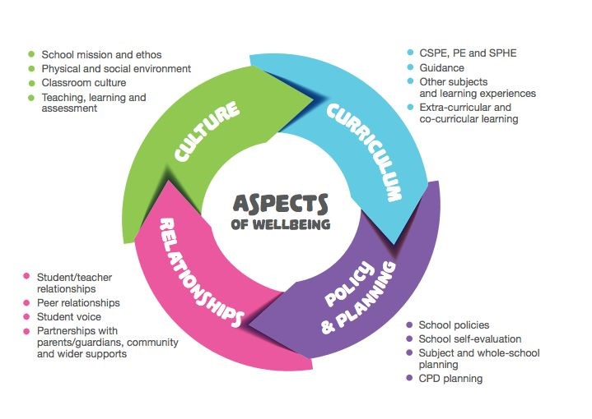
In addition to these formal subjects Gort Community School runs awareness events and short courses that fit under the heading of wellbeing and seek to benefit the lives of our students.

These include (but are not limited to)
- Jigsaw​ (Mental Health workshop for all 5th Year Students)
- Galway Rape Crisis Centre workshop for all 5th year students (Staying safe in an over sexualised world)
- Aware​ Positive Mental Health programme for all 6th year students (Beat the Blues)
- Shout​ anti-bullying LGBTQ+ anti-bullying programme for all first year students
- An Garda Siochana​ Road Safety workshop for Leaving Certificate Applied students
- Run for Jamsie​ Annual 5 Kilometer, whole school run
- In house Study Skills programme​s designed to help students develop the skills to manage their academic lives

Pastoral Procedures
This school is committed to respectfully and sensitively deal with how information is received, shared, stored, and accessed. We carefully follow data protection guidelines as determined by the Department of Education and Science and by the Board of Management at Gort Community School.
We have created a Crisis​ Intervention Plan to ensure that the school is prepared for very challenging events as serious as sudden death, suicide, or serious injury. The school’s Crisis Response Policy/ Plan is​ a structured, step-by-step plan that clearly defines roles and responsibilities for each staff member of Gort Community School.

Communication
Clear communication procedures between school and home are essential to ensure the safety of students. A system of monitoring daily absenteeism and contacting parents/guardians immediately is in place at Gort Community School. In addition to this, the school follows Department of Education & Science/ Tusla guidelines in recording and reporting long term absenteeism.
Formal, Parent Teacher meetings take place for all year groups on an annual basis. Subject Teachers, Tutors and Year Heads can be available to meet Parents/Guardians on an appointment basis throughout the year, should the need arise.

Conclusion
The Pastoral Care System at Gort Community School aims to create an environment in which excellence in learning. growth and responsibility flourish. This document sets out a summary of what we aspire to achieve and the means and structures that can we have put in place in this endeavour. We, as a staff, must actively reflect upon and evaluate our contribution to Pastoral Care. Pastoral Care is​ teamwork that includes every member of our school community. This whole school approach is central to our Pastoral Care Policy. In essence, we are only as strong as our weakest link.

Appendices

Appendix i: Ladder of Referral
Appendix ii: External Support Agencies and Organisations
Appendix iii: Related School Policies and Codes
Appendix iv: External State Guidelines and Procedures

(i) Ladder of Referral

Ladder of Referral
Gort Community School

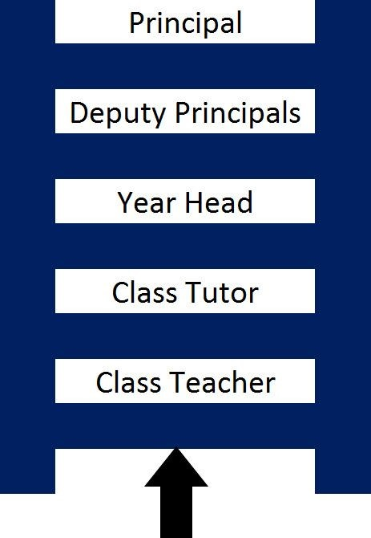

(ii) ​ External Agencies​

CAMHS | TUSLA | Co Galway ETB advocacy office
National Learning Network | Galway Mental Health Services | National Immigration Services
Gort Resource Centre

Organisation | Year Group
Shout (LGBTQ+ and Anti-Bullying) | First Year
Jigsaw (Mental Health Awareness) | Fifth Year
Galway Rape Crisis Centre (Staying Safe in an Over-Sexualised  World) | Fifth Year
Aids West | Fifth Year
Aware (Life Skills Programme) | Senior Students
Aware (Beat the Blues Positive Mental Health Programme) | Sixth Year
Garda Road Safety Presentation | LCA II and TY

(​ iii) Related School Policies and Codes:
- Code of Good Behaviour for Gort Community School and Teacher Guidelines (2017)
- Wellbeing Policy/Plan
- Health and Safety Policy
- Homework Policy
- Critical Incident Plan
- Relationship & Sexuality Policy
- Child Safeguarding Statement for Gort Community School
- Substance Abuse Policy

- SPHE policy / plan
- CSPE policy / plan
- Careers Guidance Policy
- Code of Discipline

(iv) External State Guidelines and Procedures
Children First Act 2015
Child Protection Procedure for Primary and Post Primary School 2017

